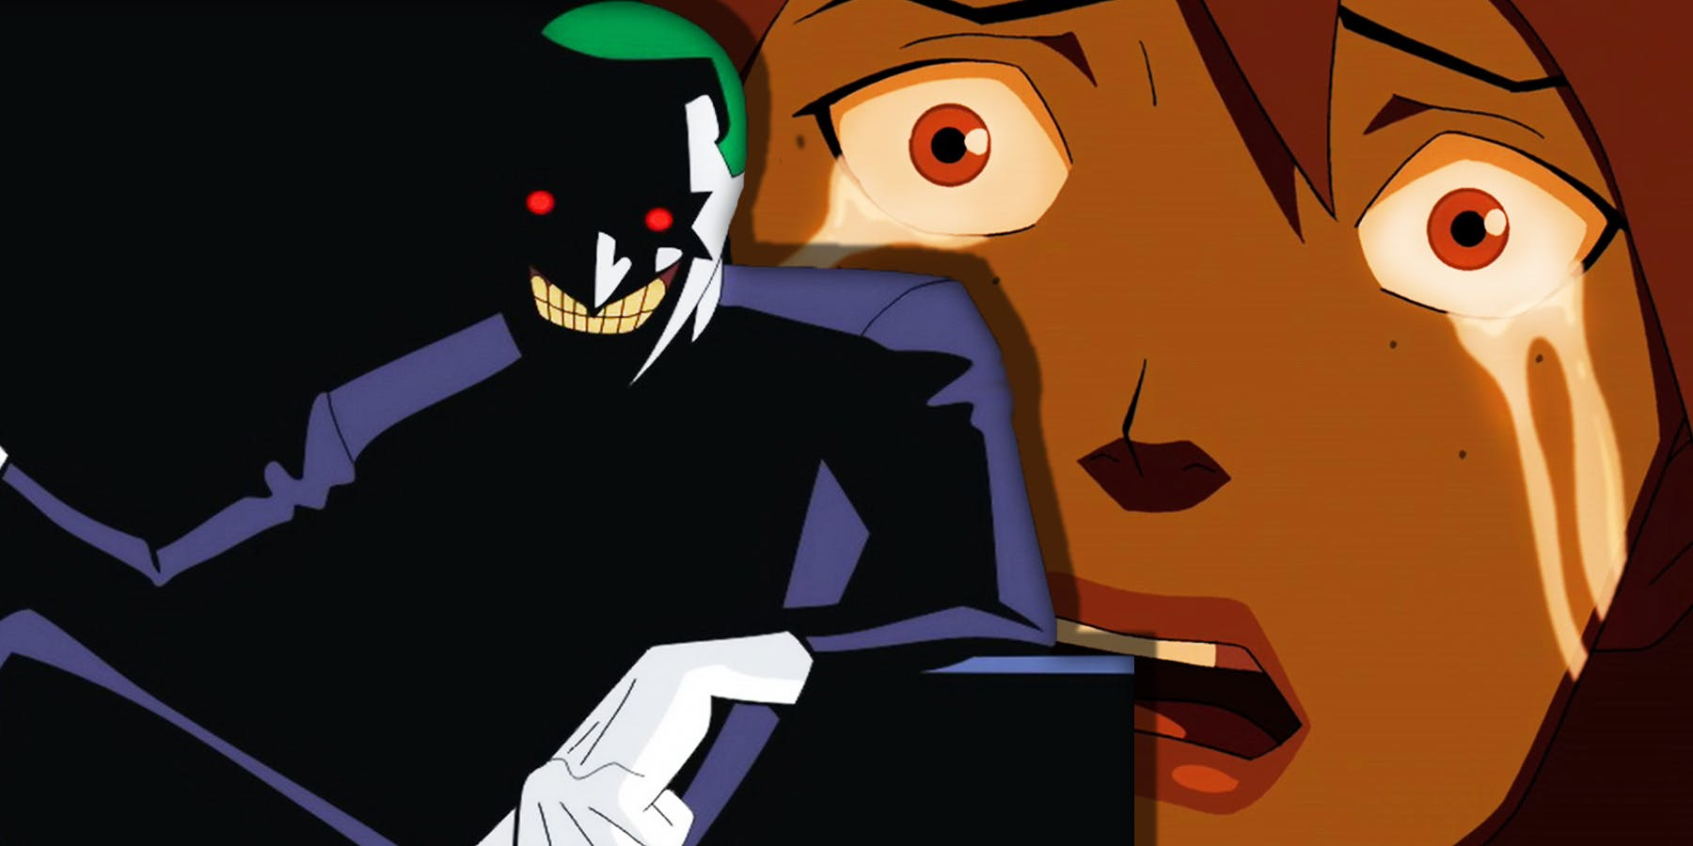

This is the story of the game. There was a person (choose boy or girl?) who was living at home but very unhappy. They are in fact depressed. The kid goes out one day and falls into an adventure. On this adventure she discovers the world around her, discovered other people have the same issues as her, discovers magic and finally discovers herself.

**Cupantae.ie Games**

**Carraroe, Co Galway**

**087 2716947**

**donalod@gmail.com**

June 2019

**Game Two**

**Game Design Document**

Contents

Section 1 - Game Identity / Mantra 4

Section 2 - Game Overview 4

2.1. Game Title: 4

2.2. Game Genre: 4

2.3. Game Perspective: 4

2.4. Game Mode(s): 4

2.5. Target Audience: 4

2.6. Core Idea: 4

2.7. Goal: 4

Section 3 - Game background 4

3.1. Background Story: 4

3.2. Characters Starting Their Story 4

Section 4 - Gameplay 5

4.1. Objectives 5

4.2. Game Logic 5

4.3. Mechanics 5

4.3.1. Rules 5

4.3.2. In-game Help and Info: 5

4.3.3. Statistics: 6

4.4. Game Resources (Score Strategy): 6

4.4.1. High Score: 6

4.4.2. Points: 6

4.5. Game Progression: 6

4.5.1. Game Levels: 6

4.5.2. Difficulty Levels: 6

4.6. Economies: 7

Section 5 - Game Elements 7

5.1. Environment: 7

5.2. Characters: 7

5.2.1. Players Characters: 7

5.2.2. Non-player characters: 7

5.3. Collectable Weapons: 7

Section 6 - Game Play I/O Controls & GUI Interfaces 8

6.1. Game Play I/O Controls: 8

6.2. GUI Interfaces: 8

6.2.1. Main Menu Interface: 8

6.2.2. Pause Menu: 9

Section 7 - Visual & Audio Features 9

7.1. Visual Features: 9

7.2. Audio Features: 9

Section 8 - System Parameters & Requirements 9

8.1. System requirements: 9

Section 9 - Creativity & Special Enhancements in Game Concept 10

9.1. Creativity & Special Enhancements Due to Third Person Perspective: 10

Section 10 - Level by Level Breakdown 10

# Game Identity / Mantra

Side scrolling beat-em-up platform where the hero coming to grips with their depression by fighting their demons and slowly regaining color in their world.

# Game Overview

## Game Title:

No title as of yet

## Game Genre:

Side scrolling beat-em-up platform

## Game Perspective:

Perspective camera following hero

## Game Mode(s):

* Single Player
* Multiplayer

## Target Audience:

* Age 13 – 25
* Fans of side scrolling platformers

## Core Idea:

Watch the world gain its color back as the hero races through levels, purchases better items and faces increasingly difficult end of level bosses with weapons and spells.

## Goal:

Get the hero out of depression by finishing the game and bringing all the color back into the players life

# Game background

## Background Story:

This is the story of the game. There was a person (choose boy or girl?) who was living at home but very unhappy. They are in fact depressed. The kid goes out one day and falls into an adventure. On this adventure she discovers the world around her, discovered other people have the same issues as her, discovers magic and finally discovers herself. She realises that she is depressed and that is okay. Note: She does not cure her depression – she just learns to live with it. Note also that we will not mention doctors – shall not villainies doctors at all.

## Characters Starting Their Story

Who is the character that you are playing. What do they look like? Describe as much as you can about family background, hobbies, who they like on YouTube, what is their school like, what friends do they have. What food do they like to eat? Are they fit? Do they read, have pets, are they pretty, ugly or normal? Everything we say here about the character are things that we can use again in the game.

# Gameplay

## Objectives

Bullet point below the gameplay objectives.

## Game Logic

* Will object have “life” like hit points? Can items be used up or “break”. If I have a gun if it shoots too many bullets it will break? Like in Minecraft, will an axe break if i use it too many times?
* Player cannot lift things that are too heavy – will items have weight?
* Can player run faster than character in real life?
* Enemies have basically same rules to follow as player.

## Mechanics

### Rules

* Characters cannot jump out of windows.
* If the characters health reaches zero then that character dies and that level needs to be repeated.
* Characters can only use a weapon a certain amount of times?
* Different weapons have a different amount of times that they can be used?
* Characters cannot get through doors without a key?
* The player cannot progress to the next level without completing the previous leve?
* Characters cannot run through walls or doors that are closed.
* Player starts with no weapons and collects weapons on the way.
* If the players character is killed by an enemy then the level must be started again.

### In-game Help and Info:

* When the game starts up the player is prompted to do the following actions (to help understand how to play the game):
  + Move around
  + Look around
  + Punch
  + Interact with objects
  + Look for key card in the room
  + Interact with the key card – pick it up and use it to open the door
* Hints:
  + When the character looks directly at an object that can be used as a weapon it glows
  + When the character looks directly at a key card it glows
* Help can be accessed via the main menu. This will include help on the following topics:
  + What the different weapon colours mean
  + How to move around
  + Information on the different zombies
  + HUD explanation
  + Information on key cards and doors
  + Goals of the game
  + Levels of the game
  + Difficulty levels

### Statistics:

* High score – overall high score for the whole game
* High scores for each of the levels
* The highest amount of health that the character has at the end of a game
* Leaderboard (Maybe a steam leader board, do not even know what that is but I know it exists and we should look into it)

## Game Resources (Score Strategy):

### High Score:

* Score is determined by how many zombies the player kills
* Score is the amount of points awarded to the player for different tasks

### Points:

* Different zombies are worth different amounts of points
* The larger staff zombies are worth more points than the smaller student zombies
* Points can be used to access items from the vending machine
* Items from the vending machine increase the characters health, however these points used in the vending machine are deducted from the players overall score

## Game Progression:

### Game Levels:

* The levels are the different floors of the central block of the MMU JD building
  + Floor 3 of the building is level 1 of the game
  + Floor 2 of the building is level 2 of the game
  + Floor 1 of the building is level 3 of the game
  + Ground floor of the building is level 4 of the game
* Different weapons are available on different levels of the game i.e. the higher the level the better the weapons
* To complete a level :
  + The player must of gone across the whole floor to the stairs at the other end of the floor
  + The player must of found a staff ID card to access the door to the stairs o The player must get onto the stairs

### Difficulty Levels:

* Easy, medium and hard
* User can choose difficulty level to play at
* The harder the difficulty level the higher the zombies health – making them harder to destroy/escape
* The harder the difficulty level the lower the weapons health – weapons cannot be used as many times

## Economies:

* Currency = points
* Payoffs = better weapons

# Game Elements

## Environment:

* The location of the game is the Manchester Metropolitan University, John Dalton building. It is the central block of this building
* Closed world
* There are different types of rooms in this central block:
  + Computer labs
  + Technicians offices
  + Lecture theatres
  + Cafeteria
  + Offices
* The lifts do not work due to the building being on lock down.
* There are four floors of this building

## Characters:

### Players Characters:

* At the beginning of the game the player will choose their character from three choices:
  + Kyle
  + Emma
  + Zubin

### Non-player characters:

* Zombies o Student zombies – smaller and easier to kill
  + Staff zombies – bigger and harder to kill
  + Scared student

## Collectable Weapons:

* Level One:
  + Keyboard
  + Mouse
  + Cups/Mugs
* Level Two:
  + Keyboard
  + Mouse
  + Cups/Mugs
  + Text books
  + Fire Extinguisher
* Level Three:
  + Keyboard
  + Mouse
  + Cups/Mugs
  + Text books
  + Fire Extinguisher
  + Broom
  + Chair
  + Laptops
* Level Four:
  + Keyboard
  + Mouse
  + Cups/mugs
  + Text books
  + Fire extinguisher
  + Broom
  + Chair
  + Laptops
  + Cutlery
  + Trays
  + Guitar
  + Tennis racket
  + Hockey sticks
  + Tennis ball

# Game Play I/O Controls & GUI Interfaces

## Game Play I/O Controls:

* Keyboard
* Mouse
* To move around the environment:
  + Arrow keys
  + W, A, S and D keys
  + Special keys:
    - Space = jump
    - E = interaction (e.g. open doors)
    - Right click on mouse = throw weapon
    - Left click on mouse = hit with weapon
    - Esc = pause
* Possible to use a joystick

## GUI Interfaces:

### Main Menu Interface:

* Options:
  + Mode: single or multiplayer
  + Level: easy, medium or hard
  + Options: audio, volume, video, controls
  + Help: different help topics
  + Statistics: high score, other scores
  + Exit: exit the game

### Pause Menu:

* Options:
  + Resume: resume the game
  + Options: audio, volume, video, controls
  + Exit: back to main menu

# Visual & Audio Features

## Visual Features:

* HUD:
  + Top left - current level and floor
  + Top right – points
  + Bottom left - health bar
  + Bottom right - weapons available, the condition of the weapon is colour coded (good=green, ok=orange, bad=red)
* Lights flicker on and off
* Lightning flashes through window
* Shadows due to different lights

## Audio Features:

* Footsteps – different footsteps on different floors
* Zombie noises (closer to a zombie the louder the noise)
* Broken lift noise
* Opening doors
* Using weapons
* Dropping items
* Picking up items
* Lightning, thunder and rain
* Computer noise – starting up

# System Parameters & Requirements

## System requirements:

* Keyboard
* Mouse
* Monitor
* 1GB RAM
* Dual-core processor
* Speakers (optional)
* Hard drive
* Graphics memory
* Windows XP or Windows Vista or Windows 7
* DirectX

# Creativity & Special Enhancements in Game Concept

## Creativity & Special Enhancements Due to Third Person Perspective:

* Third person makes the game more complicated
* Dynamic shadows needed
* Avatar actually has to hold weapons/objects
* The view for the player is going to be wider
  + Can see a bit behind the avatar
  + Need to think about being attacked from behind
* Sound effects – for example when an avatar is walking sound effects will be needed in time to the footsteps being taken

# Level by Level Breakdown

Level 1 – The demon is simply getting out of bed. What is a bed demon? Basically the biggest challenge is just getting up. Doing the 100% “normal” things. Brushing your teeth. Getting dressed.

Level 2 – Interacting with people. Talking to people. Interacting. You can see that everyone talks mundane boring crap most of the time, but others cannot! You want to mix with them, but it is difficult to make conversation. What is a “speak normal boring everyday conversation” demon. What does it look like.

Level 3 – Chores. Take out the bin. Tidy your bed! What are all the little things that you have to do before leaving the house. I can imagine a “trash can” demon!

Level 4 -